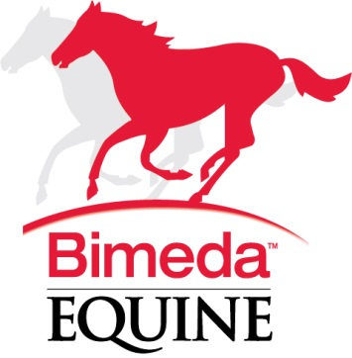
25th January 2017

Bimeda Equine Wormer Promotion
– United Farmers

Bimeda Equine is offering United Farmer members the opportunity to take advantage of some additional rebate on their two equine wormers.
Offers run until the end of March 2017 and orders can be placed direct using the following email address: uksales@bimeda.com.

The two equine wormers are an Apple Flavoured Ivermectin wormer (Bimectin Oral Paste) and a Pyrantel wormer (Embotape Oral Paste).

Wormer | List Price | Net Price | Net Price after 5% rebate |  | Offer | Offer rebate | Net Price | Net Price after offer rebate and standard 5% rebate
Bimectin  (Apple Flavoured) | £7.47 | £3.97 | £3.60 |  | Additional 12% | £0.90 | £3.07 | £2.70
Embotape | £8.22 | £4.37 | £3.96 |  | Additional 8% | £0.66 | £3.71 | £3.30
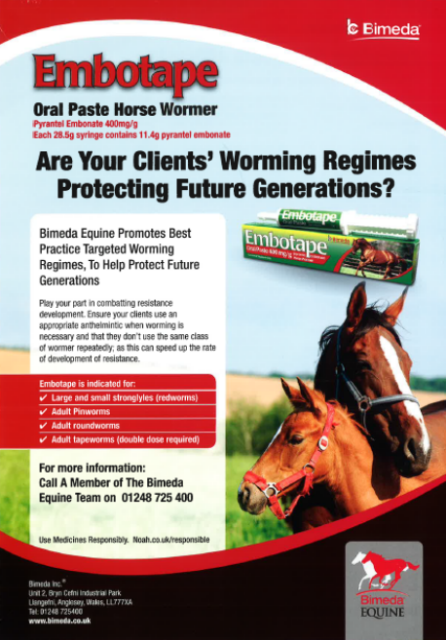

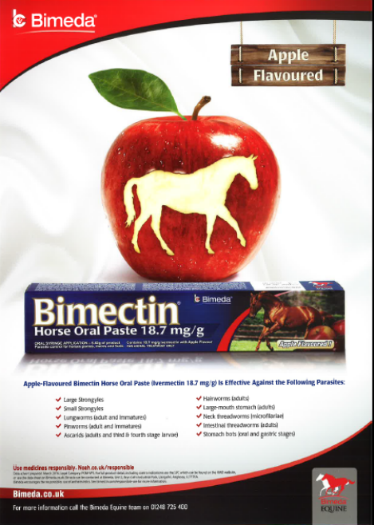
For any further information please contact your Bimeda Territory Manager or Key Account Manager Emma Wormington
(Contact details below).

Emma Wormington | Territory Manager (South East) and Key Account Manager

M+44 7889 809267 | T +44 1248 725400 | F +44 1248 725416
ewormington@bimeda.com |

Support literature available for Horse Owners

Bimeda Equine can also offer support literature aimed at the horse owner. These include a 16 page best practice guide to worming and an A4 planner allowing the horse owner to record FEC results and worming information including wormer administered.
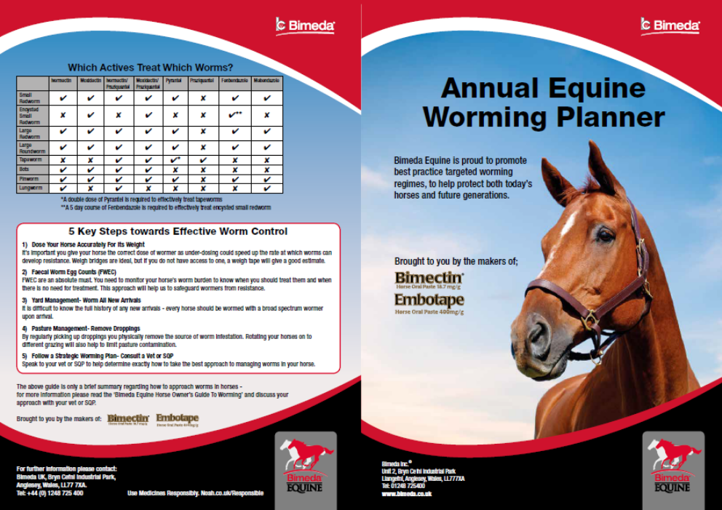

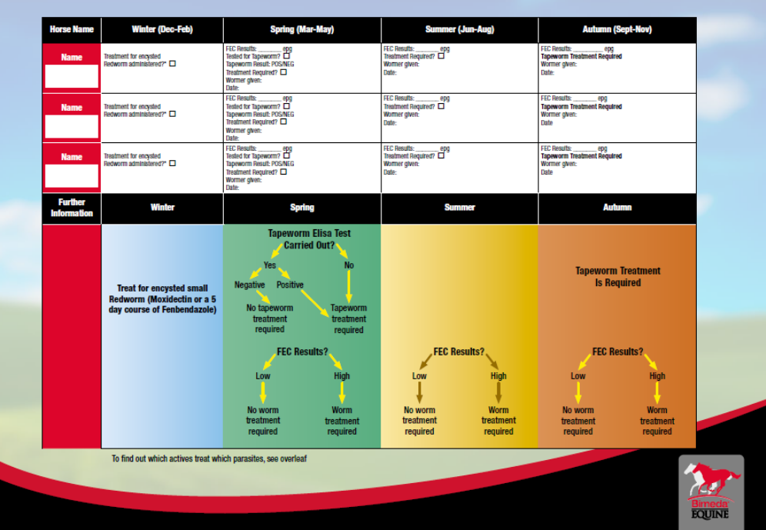

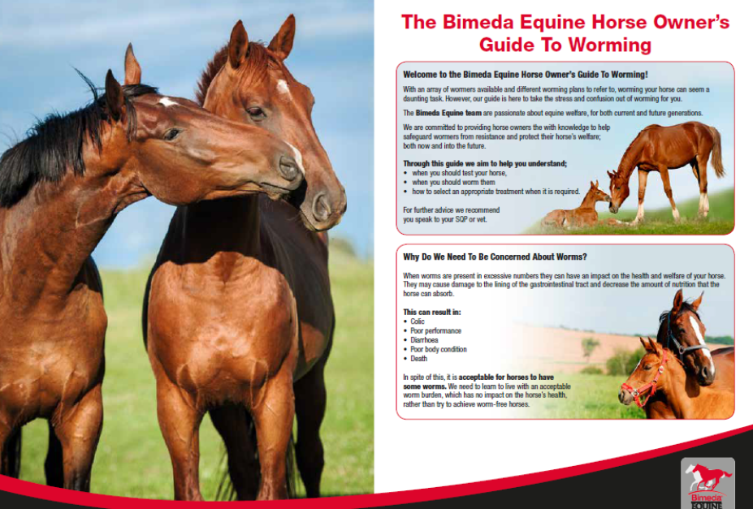
These are available to all UF members – to order some of the materials please contact your Territory Manager or Key Account Manager Emma Wormington.

Emma Wormington | Territory Manager (South East) and Key Account Manager

M+44 7889 809267 | T +44 1248 725400 | F +44 1248 725416
ewormington@bimeda.com | www.bimeda.co.uk

